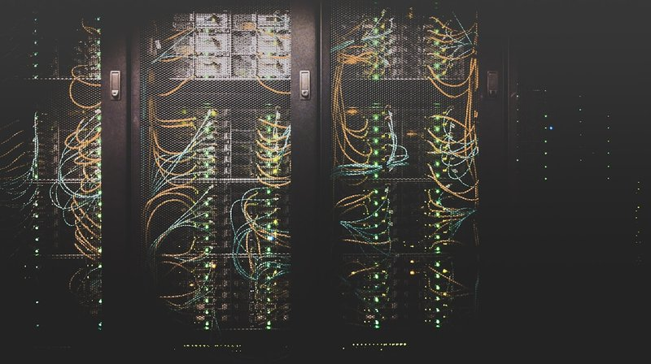
AI NATIVE DISTRIBUTED DATACENTERS
A Technical Architecture for Sovereign, Resilient,
AI-Managed Edge Infrastructure
ANDD Network | Whitepaper v1.0 | March 2026
contact@andd.network | andd.network

Table of Contents
1. Executive Summary
2. The Case for Decentralization
3. ANDD Architecture Overview
4. Technical Architecture
5. Bandwidth & Connectivity Requirements
6. Energy Requirements & Mitigation Strategies
7. AI-Native Operations
8. Resilience Through Decentralization
9. Payment Architecture
10. DePIN Integration & Pressure Test
11. Opportunity Zone Alignment
12. Implementation Roadmap
13. Conclusion

1. Executive Summary
The global compute infrastructure serving AI, critical services, and digital economies is dangerously concentrated. Fewer than 30 hyperscale campuses in the United States process the vast majority of AI inference, financial transactions, government data, and emergency communications. This concentration creates single points of failure for national security, economic continuity, and community resilience — and it leaves underserved regions permanently behind.
The ANDD Vision
A network of hundreds to thousands of sub-2MW edge datacenters, deployed across federally designated Opportunity Zones, forming an interconnected mesh fabric that is entirely managed and operated by artificial intelligence. No human operators provision servers. No human billing clerks process invoices. The AI management layer handles customer onboarding, capacity planning, workload routing, billing, compliance reporting, and predictive maintenance autonomously.

<2MW | 100s+ | 4 | 99.99%
Per Datacenter | Edge Locations | Hardware Domains | SLA Target

This whitepaper presents the technical architecture, infrastructure requirements, and economic model for the ANDD network. It details the four hardware domains (Compute, Storage, Connectivity, AI Accelerators), the bandwidth and energy profiles for each site, mitigation strategies for power resilience through renewables and microgrids, and the payment architecture spanning fiat subscriptions to real-time crypto micro-transactions.
Critically, it pressure-tests the ANDD model against the track record of existing Decentralized Physical Infrastructure Network (DePIN) projects — analyzing why consumer-grade approaches have struggled and how enterprise-grade, AI-native infrastructure resolves those failure modes.
 | 
Smart City Infrastructure | AI at the Edge

2. The Case for Decentralization

2.1 The Concentration Problem
The current datacenter landscape in the United States is defined by extreme geographic concentration. Northern Virginia alone hosts over 70% of internet traffic on the East Coast. The top five metro markets (Northern Virginia, Dallas-Fort Worth, Phoenix, Chicago, Silicon Valley) account for a disproportionate share of total U.S. datacenter capacity.

Global network infrastructure — concentrated and vulnerable
This concentration creates compounding vulnerabilities:
- National Security Exposure. A coordinated attack on fewer than a dozen campuses could degrade federal agencies, financial markets, and defense communications simultaneously. Geographic clustering means a single regional disaster threatens a nationally significant share of compute capacity.
- Latency Inequality. Communities more than 50ms from the nearest hyperscale region cannot participate in latency-sensitive applications: real-time AI inference, telemedicine, autonomous vehicle coordination, AR/VR. The digital divide is not merely a bandwidth problem; it is a proximity problem.
- Sovereignty Erosion. Government data, municipal systems, and critical infrastructure become dependent on the operational decisions and pricing power of three to four hyperscale vendors.
- Grid Strain. A single 300MW campus demands the equivalent output of a small natural gas plant. Dominion Energy in Virginia has cited datacenter load growth as the primary driver of new generation capacity.

2.2 Why Distributed Edge, Why Now
Three converging trends make the distributed edge datacenter model not only viable but urgent:
AI Inference is Moving to the Edge
While training remains centralized, inference — 60-70% of all AI compute — is increasingly latency-sensitive and geographically distributed. Autonomous vehicles need sub-10ms inference. Smart-city sensors generate data that loses value traversing 2,000 miles to a hyperscale region.

DePIN Requires Enterprise-Grade Infrastructure
Projects built on consumer hardware have hit reliability ceilings. Enterprise customers require 99.99% uptime, N+1 redundancy, physical security, and compliance certifications that consumer-grade nodes cannot provide.

Federal Policy Now Incentivizes Distribution
The Opportunity Zone program (8,764 designated census tracts), bipartisan AI infrastructure interest, and rural broadband initiatives create an unprecedented policy tailwind.

2.3 The AI-Native Differentiator
Previous attempts at distributed datacenter networks failed primarily on operational economics. A sub-2MW facility cannot justify full-time site managers, network engineers, and facilities technicians. ANDD inverts this equation by making AI the operator. When all operations are handled by autonomous AI systems, the marginal cost of adding a new site approaches the cost of the hardware and connectivity alone. This is the economic unlock that makes distributed viable for the first time.

3. ANDD Architecture Overview

3.1 Network Topology
The ANDD network is organized as a three-tier mesh fabric:
Tier | Component | Power Class | Quantity | Connects To
Tier 3 | AI Control Plane | Distributed | 1 (logical) | All Regional Hubs (consensus)
Tier 2 | Regional Hubs | 1–2MW | 3+ initially | Control Plane + 5–15 Edge Nodes + Peering Exchanges
Tier 1 | Edge Nodes | 200kW–500kW | 100s–1000s | Regional Hub + Adjacent Edge Nodes (mesh) + 2nd Hub (redundant)


ANDD edge node — enterprise-grade, modular, deployable in 60–90 days
Tier 1 — Edge Nodes (200kW–500kW). The atomic unit of the network. Modular, prefabricated facilities deployable in 60-90 days. Each contains a configurable mix of compute, storage, connectivity, and AI accelerator hardware.
Tier 2 — Regional Hubs (1–2MW). Aggregation points providing higher-density compute, regional storage caching, peering interconnection, and backhaul concentration. Each serves 5–15 edge nodes.
Tier 3 — AI Control Plane (Distributed). A distributed consensus system running across all regional hubs. Handles global workload routing, billing reconciliation, capacity planning, and AI model updates. Byzantine fault-tolerant.

3.2 Mesh Interconnection
Every edge node maintains four types of connectivity:
Connection Type | Medium | Bandwidth | Purpose
Primary Uplink | Fiber / Licensed Microwave | 10+ Gbps | Primary backhaul to regional hub
Redundant Uplink | Diverse Fiber / 5G / LEO Satellite | 1–10 Gbps | Backup path via different route
Mesh Peering | Direct node-to-node | 10 Gbps | Local traffic exchange and failover
2nd Hub Path | Via mesh or direct | Variable | Ensures no single hub failure isolates node

3.3 Single-Site Physical Layout
System Layer | Components | Specification
IT Equipment | Compute Racks (x4–8), AI Accelerator Racks (x2–4), Storage Racks (x2–4) | Configurable mix based on local demand
Network Fabric | Top-of-Rack / Leaf-Spine Switches | 100GbE / 400GbE internal
Network Edge | Edge Router / Firewall | BGP peering, SD-WAN, encryption
External Links | Primary + Redundant Uplinks | Fiber 10G+ primary; 5G/Satellite backup
Power | Utility + ATS + Li-Ion UPS + Optional Solar/Fuel Cell | 15–30 min UPS runtime; microgrid capable
Cooling | Direct Liquid Cooling + Ambient Air Economization | Target PUE 1.15–1.25

4. Technical Architecture

4.1 Four Hardware Domains

4.1.1 Compute
Component | Specification
Platform | High-density 1U/2U servers, ARM and x86
Processors | AMD EPYC 9004 / Intel Xeon 6 / Ampere Altra Max
Memory | 256GB–1TB DDR5 per node
Density | 20–40kW per rack
Use Cases | Containerized workloads, VM hosting, CI/CD, general-purpose

4.1.2 Storage
Component | Specification
Hot Tier | NVMe SSD arrays, 100TB–500TB per site
Warm Tier | QLC SSD / high-density HDD, 500TB–2PB per site
Protocol | S3-compatible object, NFS/SMB block, distributed file system
Replication | Erasure coding across 3+ nodes; 11 nines durability
Use Cases | CDN caching, data lakes, AI training data, backup

4.1.3 Connectivity
Component | Specification
Internal Fabric | 100GbE leaf-spine, upgradable to 400GbE
Backhaul | 10–100 Gbps fiber (primary), diverse redundant path
Peering | Direct peering with regional ISPs, CDNs, cloud on-ramps
Wireless | 5G/LTE-A small cells, CBRS spectrum
Specialized | Defense network interconnection (SIPRNet/NIPRNet capable)

4.1.4 AI Hardware
Purpose-built AI accelerators power inference at the edge
Accelerator | TDP | Memory | Memory BW | Deployment
NVIDIA L4 | 72W | 24GB GDDR6 | 300 GB/s | Edge Node (efficient inference)
NVIDIA L40S | 300W | 48GB GDDR6X | 864 GB/s | Edge Node (inference)
AMD MI300X | 750W | 192GB HBM3 | 5.3 TB/s | Edge Node / Hub (inference)
AMD MI325X | 750W | 256GB HBM3e | 6.0 TB/s | Edge / Hub (large models)
Intel Gaudi 3 | ~600W | 128GB HBM2e | 3.7 TB/s | Edge (cost-efficient)
NVIDIA H100 SXM | 700W | 80GB HBM3 | 3.35 TB/s | Regional Hub (training)
NVIDIA H200 SXM | 700W | 141GB HBM3e | 4.8 TB/s | Regional Hub (large models)
NVIDIA B200 | 1,000W | 192GB HBM3e | 8.0 TB/s | Regional Hub (training)
NVIDIA GB200 NVL2 | 2,700W | 384GB HBM3e | 16 TB/s | Hub (liquid-cooled)

Edge AI Workload Feasibility:
Workload | Hardware | Power | Latency
LLM inference (7–13B) | 1x L40S or MI300X | 300–750W | 20–100ms/token
LLM inference (70B) | 2–4x H100 PCIe | 700W–1.4kW | 50–200ms/token
Real-time image/video | 1x L4 | 72W | 5–20ms
Speech recognition | 1x L4 | 72W | <100ms
Recommender systems | 2–4x GPU + CPU | 1–3kW | 10–50ms
RAG | 1–2x H100 + vector DB | 1–2kW | 100–500ms
Fraud detection | 1x L40S | 300W | <50ms
Medical imaging | 1x L40S | 300W | <1s

4.2 Software Stack
Layer | Component 1 | Component 2 | Component 3
AI Management | Onboarding Agent | Provisioning Agent | Billing + SLA Monitor
Orchestration | Kubernetes (K3s/RKE2) | Service Mesh (Istio) | AI-Optimized Scheduler
Infrastructure | SDN (OVS/VPP) | Storage (Ceph/MinIO) | DCIM/BMS (AI-Controlled)
Hardware Abstraction | BMC/IPMI/Redfish | GPU Driver Layer | Switch OS (SONiC/Cumulus)

4.3 Security Architecture
- Zero-trust networking. Every workload-to-workload communication is mTLS encrypted. No implicit trust based on network location.
- Hardware root of trust. TPM 2.0 on all servers. Measured boot. Remote attestation verifies node integrity cryptographically.
- Tenant isolation. SR-IOV for network, SEV-SNP/TDX for confidential computing, separate encryption keys per tenant.
- Physical security. Biometric access, 24/7 AI-monitored surveillance, tamper-evident racks. SCIF-compatible options.
- Compliance. FedRAMP, SOC 2, HIPAA, CJIS, ITAR compliance paths built in from day one.

5. Bandwidth & Connectivity Requirements
Site Tier | Primary Uplink | Redundant | Mesh | Total Backhaul
Edge Node (200kW) | 10 Gbps | 1–10 Gbps | 10 Gbps | 20–30 Gbps
Edge Node (500kW) | 40 Gbps | 10 Gbps | 25 Gbps | 50–75 Gbps
Regional Hub (1–2MW) | 100 Gbps | 40 Gbps | 100 Gbps | 200–300 Gbps


Multi-carrier connectivity ensures resilient backhaul

Backhaul by Site Type
Site Type | Primary | Bandwidth | Backup | Backup BW
Urban | Dark/Lit Fiber (multi-carrier) | 10–40 Gbps | 5G/LTE-A | 1–5 Gbps
Suburban | Fiber (1–2 carriers) | 10–40 Gbps | Diverse Fiber | 10 Gbps
Rural | Licensed Wireless / LEO Sat | 1–10 Gbps | 5G/LTE-A | 500M–1 Gbps

Protocol Stack
- Underlay: eBPF-accelerated IP routing with segment routing (SRv6)
- Overlay: WireGuard/MACsec encrypted tunnels; VXLAN/GENEVE tenant isolation
- Peering: Automated BGP with RPKI validation and route leak detection
- DNS: Anycast DNS across all nodes for automatic geo-routing
- Load Balancing: AI-driven GSLB factoring latency, capacity, energy cost, carbon intensity

6. Energy Requirements & Mitigation Strategies
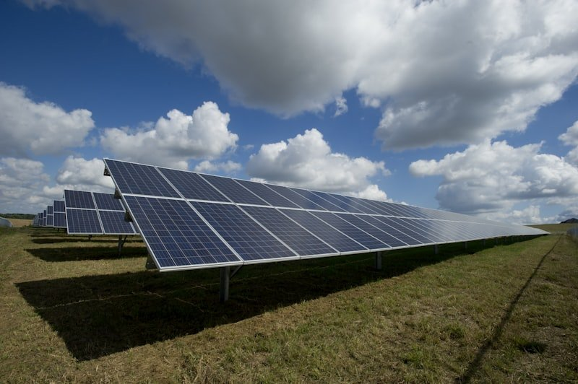
On-site solar generation offsets 30–50% of facility energy consumption

6.1 Per-Site Power Profile
Site Tier | IT Load | Cooling | Infra | Total | Target PUE
Edge Node (200kW) | 150kW | 25kW | 25kW | 200kW | 1.15–1.25
Edge Node (500kW) | 380kW | 65kW | 55kW | 500kW | 1.15–1.25
Regional Hub (2MW) | 1,500kW | 280kW | 220kW | 2,000kW | 1.15–1.25

PUE Benchmarks — ANDD vs. Industry:
Facility Type | Typical PUE | Best-in-Class | Primary Cooling
Hyperscale (Google, Meta) | 1.10–1.20 | 1.06–1.08 | Evaporative + liquid
Large colocation | 1.30–1.50 | 1.15–1.25 | Chilled water + air
Traditional edge (<1MW) | 1.40–1.80 | 1.20–1.30 | DX air conditioning
ANDD Edge (purpose-built) | 1.15–1.25 | 1.02–1.10 | DLC + immersion

6.2 Cooling Technology Comparison

Direct liquid cooling eliminates the traditional edge efficiency penalty
Technology | Cooling Power (500kW site) | Effective IT | PUE | Capital Premium
Air cooling (DX) | 150–200kW | 300–350kW | 1.40–1.80 | Baseline
Rear-door heat exchangers | 75–125kW | 375–425kW | 1.20–1.40 | +15–25%
Direct-to-chip liquid | 40–75kW | 425–460kW | 1.10–1.20 | +25–40%
Single-phase immersion | 15–30kW | 470–485kW | 1.02–1.06 | +30–50%
Two-phase immersion | 10–20kW | 480–490kW | 1.01–1.04 | +40–60%
Key Insight
Moving from air cooling (PUE 1.5) to immersion (PUE 1.05) saves ~300kW of cooling power in a 1MW facility — effectively increasing usable compute capacity by 30% within the same power envelope.

6.3 Renewable Integration Economics
Sizing Example — 200kW Edge Node:
Component | Specification | Cost | Annual Value
Solar Array | 100kW, carport-mounted | ~$150,000 | 175 MWh/yr generation
BESS (LFP) | 500kWh / 250kW | ~$200,000 | 2hr backup + daily cycling
IRA Tax Credit | 30–50% ITC | –$105K to –$175K | Reduces effective capital
Utility Savings | Offset + peak shaving | — | $40K–$80K/yr
Grid Services | Freq. regulation, DR | — | $50K–$200K/yr per MW
Effective payback: 2–4 years after IRA credits and grid services revenue.

6.4 Federal Funding Landscape
Program | Funding | Relevance to ANDD
DOE GRIP | $10.5 billion | Microgrids, DER, grid modernization
DOE Loan Programs Office | $400B+ lending | Clean energy, fuel cells, distributed generation
ARPA-E COOLERCHIPS | $42 million | Datacenter cooling efficiency R&D
IRA Investment Tax Credit | 30–50% | Solar, battery, fuel cells at ANDD sites
USDA REAP | Grants + loans | Rural renewable energy
NTIA BEAD | $42.45 billion | Broadband + co-located edge infrastructure

7. AI-Native Operations

AI agents manage the entire datacenter lifecycle autonomously

7.1 The Autonomous Datacenter Thesis
Traditional datacenter operations depend on human operators at every layer. These human costs establish a minimum viable facility size — typically 5MW+ — below which operations are not economically sustainable. ANDD eliminates this constraint by replacing human operational roles with specialized AI agents.

7.2 AI Agent Architecture
Agent | Function | Key Capabilities
Orchestration Agent | Coordinates all sub-agents | Conflict resolution, human escalation when confidence < threshold
Customer Onboarding | Full customer lifecycle | Lead qualification, proposals, KYC/KYB, tenant provisioning
Provisioning Agent | Infrastructure deployment | Workload-to-resource mapping, optimal node placement, auto-scaling
Billing & Revenue | Financial operations | Sub-second metering, invoicing, micro-transactions, fiat+crypto reconciliation
Predictive Maintenance | Prevent failures | Sensor telemetry, digital twins, preventive scheduling, work order dispatch
SLA Guardian | Ensure commitments | Threshold monitoring, auto-remediation, compliance reports, credit issuance

Target: 1 Human Operator per 20–50 Edge Nodes
A 10–25x improvement over traditional staffing models. Humans handle exception escalation, strategic decisions, physical maintenance, and compliance oversight. The AI handles everything else.

8. Resilience Through Decentralization
The United States’ critical infrastructure — payments, energy, communications, emergency services — has migrated to cloud systems hosted in concentrated datacenter corridors. This creates systemic risk that individual redundancy measures cannot address.

Commercial Applications: What ANDD Protects
 | 
Payments & Fintech | Emergency Services

 | 
Healthcare & Telemedicine | Government & Defense

8.1 Payments Infrastructure
The U.S. payment system processes over $10 trillion daily through networks that depend on a handful of datacenter locations. ANDD distributes payment processing — card authorization, ACH, FedNow gateways — across hundreds of edge nodes with local store-and-forward capability during backbone disruptions.

8.2 Energy Grid
ANDD nodes host distributed SCADA/EMS systems, provide sub-10ms control loops for DERs, aggregate into a virtual power plant for grid services, and island during grid emergencies to maintain critical local services.

8.3 Emergency Services & Public Safety
Local NG911 hosting, FirstNet edge compute, emergency operations center computing, satellite backhaul resilience, and community notification systems — all functioning even when terrestrial backhaul is disrupted.

8.4 Utilities & Water Systems
Local SCADA hosting for water treatment, wastewater, and gas distribution. Semi-air-gapped operation capability. AI-powered anomaly detection for contamination, leaks, and cyber intrusion at sub-second response times.

8.5 Resilience Quantification
Architecture | Uptime per Unit | System Availability | Failure Mode
Single hyperscale campus | 99.99% | 99.99% (67 min downtime/yr) | Catastrophic — total loss on failure
ANDD mesh (100 nodes, 70% needed) | 99.95% per node | 99.9999%+ network-level | Graceful degradation — linear performance decrease

9. Payment Architecture

From enterprise wire transfers to real-time crypto micro-transactions

9.1 Fiat Subscription Tiers
Tier | Model | Billing | Payment Methods | Use Case
Starter | Monthly | Post-paid, NET 30 | Credit card, ACH | Startups, developers
Professional | Monthly/Annual | Post-paid, NET 30 | ACH, wire | Mid-market, fintech
Enterprise | Annual | Custom, NET 45–60 | Wire, ACH, PO-backed | Large enterprise, telcos
Government | Annual/Multi-year | Per procurement regs | Treasury/PO systems | Federal, state, local gov

9.2 Digital & Crypto Payment Rails
Chain | Use Case | Finality | Cost per Tx
Ethereum L1 | Large enterprise contracts | ~12 min | $1–$20
Solana | High-frequency, lower-value | Sub-second | ~$0.001
Ethereum L2 (Arbitrum, Base) | Medium-frequency | Minutes | $0.01–$0.10
Payment Channels (off-chain) | Micro-transactions | Instant (off-chain) | Near-zero

9.3 Smart Contract SLAs
ANDD introduces programmable SLAs — smart contracts that encode service level commitments and automatically enforce them:
Contract Element | Logic | Purpose
Uptime Target | 9999 basis points (99.99%) | SLA threshold
Latency Target | <5ms edge latency | Performance floor
Measurement Period | 30-day rolling window | Evaluation cadence
Oracle Integration | getUptime(tenantId, period) | Verified performance data
Automated Payout | paymentToken.transfer(tenant, credit) | Instant SLA credit to tenant wallet
Event Logging | emit SLACreditIssued() | Immutable on-chain audit trail

9.4 Hybrid Payment Orchestration
Customer Type | Primary Payment | Secondary | Micro-Tx
Enterprise | Wire / ACH (annual) | Credit card (overage) | N/A
Government | PO / Treasury | ACH | N/A
Startup | Credit card (monthly) | USDC | Per-API-call
DePIN Project | Stablecoin | Payment channel | Per-request
Web3 Native | USDC / token | Payment channel | Per-request

10. DePIN Integration & Pressure Test
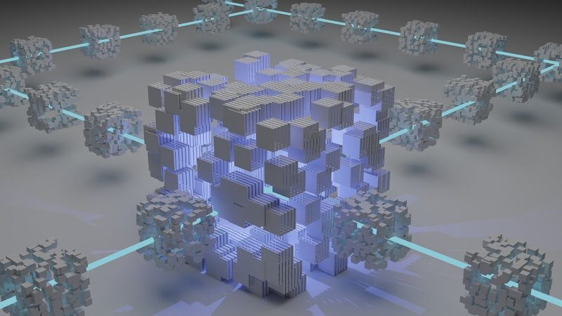
DePIN — the promise of decentralized physical infrastructure meets enterprise reality

10.1 Case Studies: Lessons from DePIN Projects
Project | What Worked | What Failed | ANDD Lesson
Helium | 900K+ hotspots globally; proved token incentives bootstrap networks | Over-provisioned where enthusiasts live, not where demand is; consumer hardware = no SLA | Location must be demand-driven; enterprise hardware required
Filecoin | 22+ EiB storage; cryptographic proof-of-storage | Mostly empty "committed capacity"; favors industrial miners; slow retrieval | Incentives tied to utilization, not capacity
Render | Real 3D rendering demand; millions of jobs processed | Consumer GPUs can't guarantee uptime, thermal mgmt, or ECC for AI inference | AI compute must be datacenter-grade
Akash | 70–85% cheaper than hyperscale; functioning marketplace | Inconsistent uptime; no SLA enforcement; enterprise won't trust anonymous providers | Smart contract SLAs + enterprise facilities = trust layer
io.net | Distributed GPU clustering for AI/ML | Heterogeneous consumer GPUs; inter-node latency kills training; benchmark ≠ production | Homogeneous, co-located hardware within each site

10.2 The Enterprise-Grade Gap
Dimension | Consumer DePIN | ANDD
Uptime | 90–98% (best effort) | 99.99% (SLA-backed)
Redundancy | None | N+1 power, cooling, network
Physical Security | None | Biometric, surveillance, tamper-evident
Compliance | None | FedRAMP, SOC 2, HIPAA, CJIS
Power Quality | Residential (variable) | UPS + BESS + generator/fuel cell
Cooling | Consumer fans | DLC, immersion, AI-optimized
Connectivity | Residential broadband | Multi-provider, redundant, SLA-backed
Data Sovereignty | Unknown | Configurable per-tenant geo-restrictions

ANDD Completes DePIN
ANDD does not compete with DePIN projects — it completes them. The tokenomics and demand aggregation work; the physical infrastructure layer needs upgrading to enterprise grade. ANDD provides that backbone.

10.3 What Can Be Built on ANDD
ANDD as infrastructure enables an ecosystem of applications and services that require reliable, distributed, low-latency compute:
Smart City & IoT | Telemedicine & Health AI


Community Connectivity | DePIN & Web3 Protocols

Application Category | Examples | Why ANDD is Required
Smart City & IoT | Traffic management, environmental sensors, connected streetlights, digital twins | Sub-10ms latency for real-time control; local data processing
Autonomous Vehicles | V2X communication, HD map updates, real-time inference | Safety-critical latency requirements; geographic coverage
Telemedicine & Health AI | Remote diagnostics, medical image analysis, patient monitoring | Data residency (HIPAA), low latency, high availability
Edge AI / MLOps | Model serving, fine-tuning, RAG pipelines, AI agents | GPU at the edge; avoid round-trip to hyperscale
DePIN Protocols | Decentralized compute, storage, wireless, sensing networks | Enterprise-grade backbone for consumer-proven protocols
Fintech & Payments | Real-time payment processing, fraud detection, crypto settlement | Data residency, sub-50ms latency, regulatory compliance
Content Delivery | Video streaming, gaming, AR/VR content, CDN edge caching | Bandwidth offload, latency reduction
Defense & Intelligence | Classified workloads, SIGINT processing, C2 systems | Sovereign infrastructure, defense network compatible
Emergency Services | NG911, FirstNet, incident management, community alerts | Must function during disasters when backhaul fails
Agricultural Tech | Precision agriculture, drone coordination, sensor networks | Rural coverage, local processing, low-bandwidth backhaul

11. Opportunity Zone Alignment
Building digital infrastructure in the communities that need it most

11.1 Tax Incentive Structure
Tier | Incentive | Requirement | Benefit
Tier 1 | Capital Gains Deferral | Reinvest into QOF | Defer tax on eligible gains; rolling 5-year window
Tier 2 | Basis Step-Up | Hold 5+ years | 10% step-up (30% for rural OZ via Qualified Rural OFs)
Tier 3 | 10-Year Exclusion | Hold 10+ years | Zero federal capital gains tax on all new appreciation

11.2 Per-Site Community Impact
Impact Category | Estimate (200kW Edge Node)
Construction jobs | 15–30 (6–12 month build)
Permanent operations jobs | 1–3 (technicians, supplemented by AI)
Annual property tax revenue | $50,000–$150,000
Annual utility revenue | $150,000–$300,000
Indirect economic multiplier | 1.5–2.0x direct spending
Digital infrastructure | Gigabit connectivity, AI capabilities, edge compute

12. Implementation Roadmap
Phase | Timeline | Key Milestones
Phase 1: Foundation | Months 1–12 | AI management layer; 200kW reference design; 3–5 pilot sites; SOC 2 Type I; QOF formation
Phase 2: Network Formation | Months 12–24 | 20–50 nodes; regional hubs; >90% autonomous ops; first gov customers; DePIN APIs; FedRAMP
Phase 3: Scale | Months 24–48 | 100–300 nodes; smart contract SLAs; micro-transactions; federal customers; defense integration
Phase 4: Continental Coverage | Months 48–72 | 500–1,000+ nodes; full AI autonomy; international expansion; VPP grid services; self-sustaining

13. Conclusion
The concentration of compute infrastructure into a handful of hyperscale campuses was an artifact of an era when operational economics demanded scale and AI did not yet exist as an operational tool. That era is ending.
ANDD demonstrates that AI-native operations eliminate the economic barrier to distributed deployment. When AI handles onboarding, provisioning, billing, monitoring, and maintenance, the marginal cost of adding a new edge node approaches the cost of the hardware itself.
ANDD delivers on every dimension that matters:
• Sovereignty — Compute stays where it is generated and governed
• Security — No single target can degrade the network
• Resilience — Distributed power, connectivity, and compute survive events that cripple centralized alternatives
• Equity — Advanced capabilities reach underserved communities
• DePIN Readiness — Enterprise-grade backbone for decentralized protocols
• Economic Viability — Multiple payment rails serve every customer type

The question is no longer whether distributed, AI-managed datacenter infrastructure is technically feasible. The question is how quickly it can be deployed.

ANDD is the answer.

contact@andd.network | andd.network
This document contains forward-looking statements about technology capabilities, market conditions, and business plans. Actual results may differ. Technical specifications represent design targets. Regulatory and tax information is for informational purposes and should not be construed as legal or tax advice.

